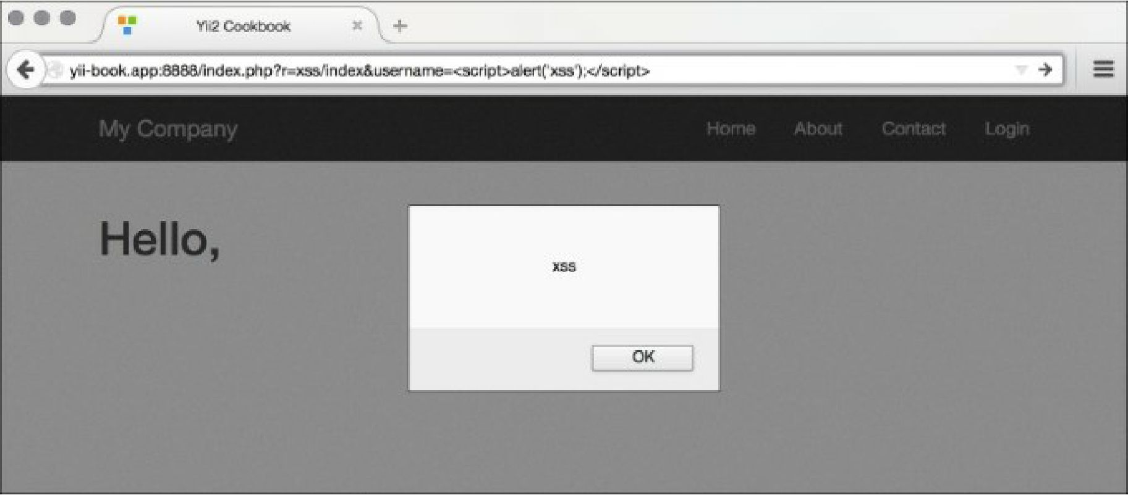

How to do it...

Carry out the following steps:

1. In order to prevent the XSS alert shown in the previous screenshot, we need to escape the data before passing it to the browser. We do this as follows:

<?php

namespace app\controllers; use Yii;

use yii\helpers\Html; use yii\web\Controller;

/\*\*

* Class SiteController.
* @package app\controllers \*/

class XssController extends Controller {

/\*\*

\* @return string \*/

public function actionIndex()

{

$username = Yii::$app->request->get('username', 'nobody');

return $this->renderContent(Html::tag('h1',

Html::encode('Hello, ' . $username . '!')

));

}

}

1. Now instead of an alert, we will get properly escaped HTML, as shown in the following screenshot: